# Introduction:

The goal of the project was to create a binary deep neural network for use in classifying images. The classifier created was used in automatically detecting whether an image was of a dog or of cat. TensorFlow was used to create the image classification neural network.

# Project Setup

To setup the project, the first step was downloading the dataset. The dataset used was downloaded from Kaggle, <https://www.kaggle.com/datasets/biaiscience/dogs-vs-cats?resource=download>. Once the dataset was downloaded, the next step was extracting the data to be used for training and testing the model. The orinigal dataset consisted of a train and test folder. Only the data in the train dataset was used for training and testing the model since it was the only one that contained labeled files. The extracted uppermost folder was then renamed to dataset.

# Model creation and testing

Once the data was obtained, the files were then split into training and testing datasets, each holding the data for the target classes, dog and cat. Exploratory data analysis was carried out to determine factors like training and testing dataset sizes and average picture size. The first few images of the target classes were then displayed.

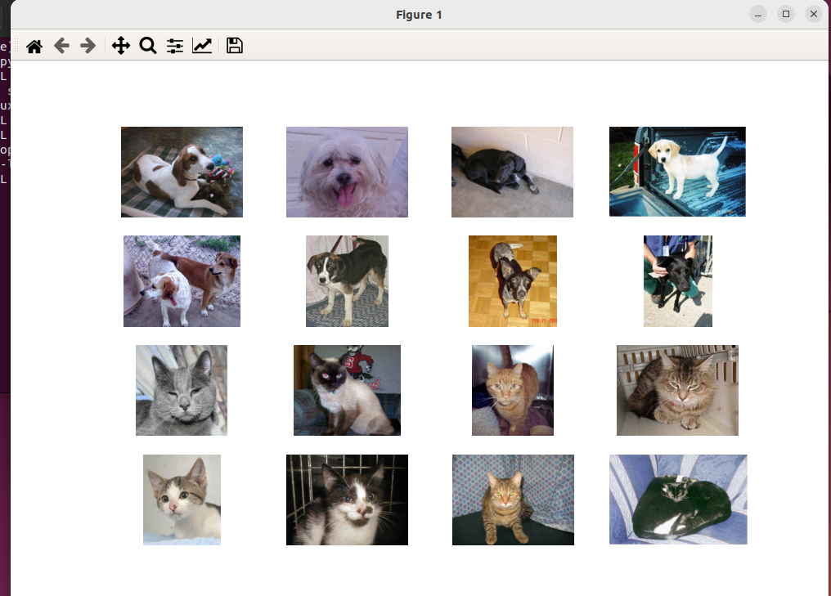

Once the datasets were created, a model was then created and trained with the training images to recognize cat and dog images. The metrics used for measuring the model was accuracy by comparing the number of true positive ratio against true negative ratio. The model was then tested and the following receiver operating characteristics obtained for two models, one with 5 epochs and 8 training and test epochs sizes and 20 epochs with 5 training and test epochs respectively.

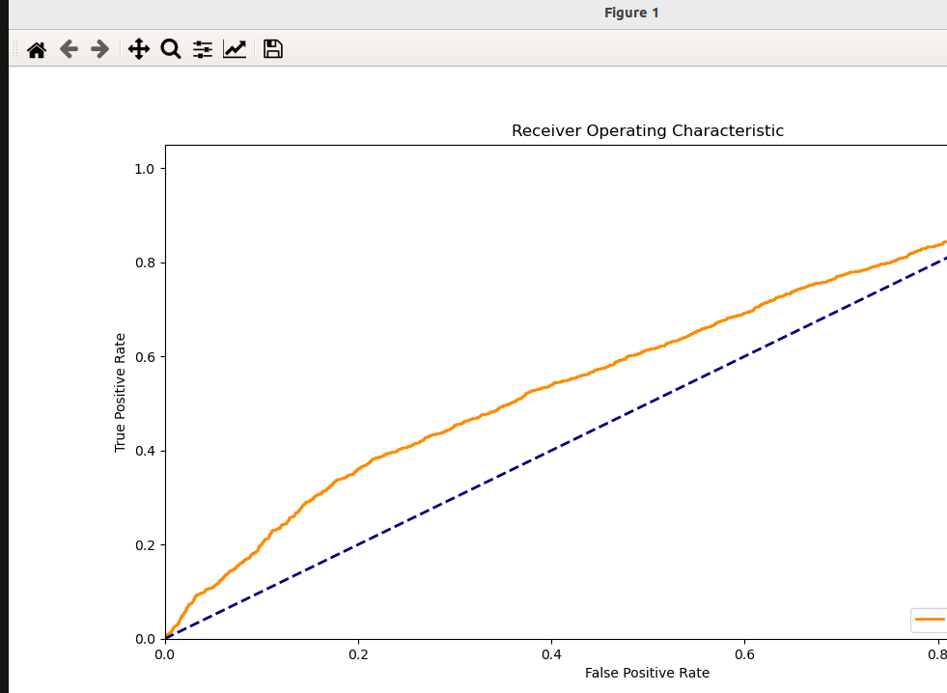

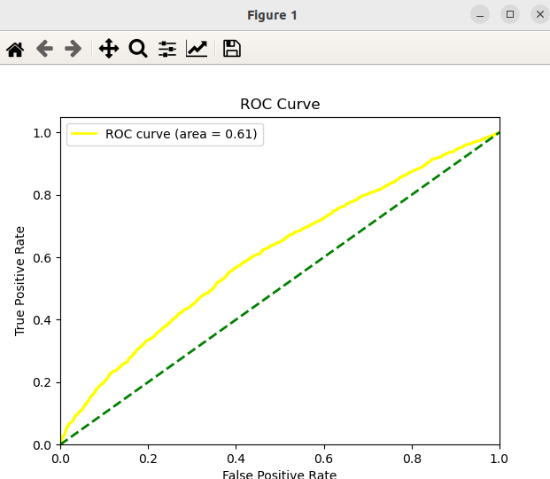

The resulting accuracy score is shown below:

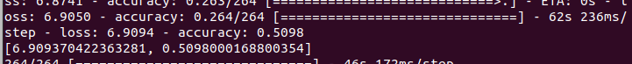

# Observations

Sufficient number of epochs are required in order for the model to converge. Deep neural network models require large amounts of data to create usable models. This is evident from the large number of files required to simply recognize two classes and the large number of trainable parameters, 15,360,257.